MODULE 01

PARTS OF SPEECH

IMPARETIVES

&

PREPOSITIONS

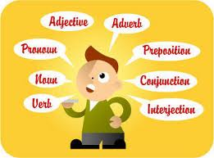
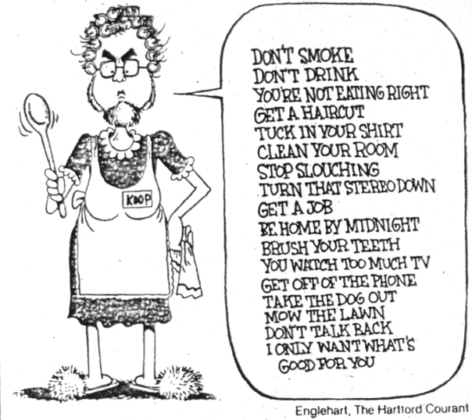

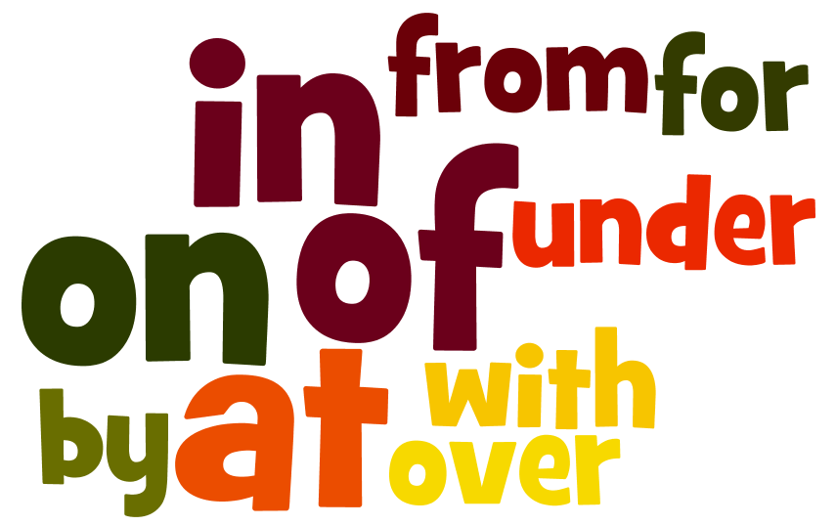

Speaking
Do small advices and errors matter in your life?
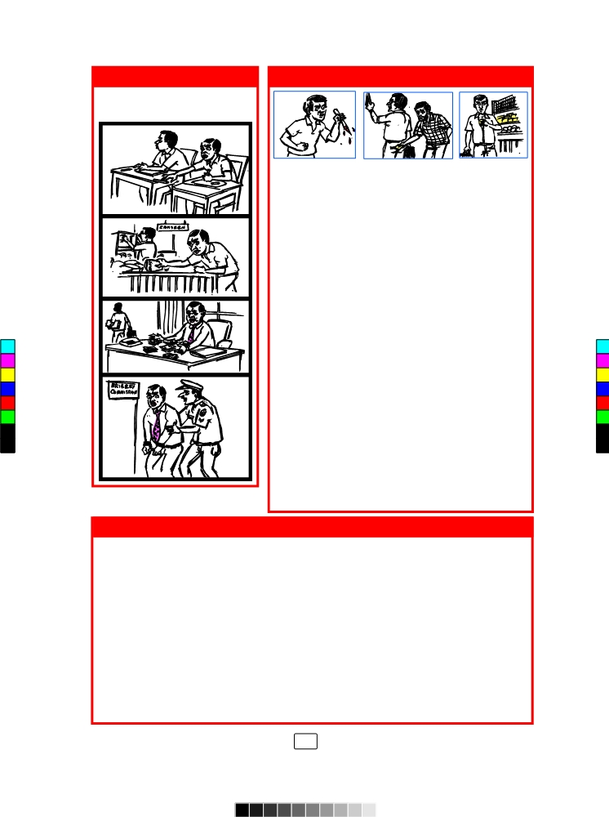
Look at the poem and the strip story below. Can you see a link between them? Discuss in your groups and say what it is.
Little Things
Little drops of water
Little grains of sand
Make the mighty ocean
And the beauteous land

And the little moments,
Humble though they be,
Make the mighty ages
Of eternity.

So our little errors
Lead the sould away,
From the paths of virtue
Into sin to stray

Little deeds of kindness,
Little words of love,
Make our earth an Eden
Like the heaven above

Julia A. Carne

Imperatives
Read the sentences given below and discuss their functions.
- Take that chewing gum out of your mouth.
- Stand up straight.
- Take two tablets every evening.
- Take a left and then a right.
- Come in and sit down. Make yourself at home.
- Please start without me. I'll be there shortly.
- Push.
- Insert one dollar.
- Speak to him. Tell him how you feel.
- Don't go. Stay at home and rest up. Get some sleep and recover.
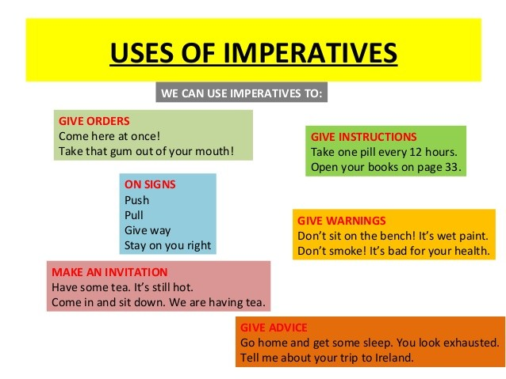
- Be quiet.

Convert these sentences to imperatives. (order/advice/intructions)
- You are expected to wear safety goggles for this laboratory exercise.
- You should wait patiently, if there is a line at a particular work station.
- You are expected to make sure to record your measurements out to the correct number of decimal places.
- It is required to return all equipment that you borrowed to its proper place, making sure to clean it thoroughly before doing so.
- All items from your lab drawer should be returned to the drawer each week.
- You are instructed not to leave lab supplies out on the counter.
New Vocabulary - Measuring weight, volume, height and mass
Inches, Yards, Hectare, Square Foot, Square Meter, Rood, Square, Pound, Atomic Mass Unit, Grain, Plank Mass, Ton, Stone, Ounces, Carats

Nouns
A word (other than a pronoun) used to identify any of a class of people, places, or things common noun, or to name a particular one of these proper noun.
- person: man, woman, teacher, John, Mary
- place: home, office, town, countryside, America
- thing: tube, Bunsen burner, beaker
Types of Nouns
 | Types of Nouns | Definition | Examples
01 | Common Nouns | Used for a class of person, place or a thing | Car, material, town, book
02 | Proper Nouns | Name of a person, place or a thing | Amal, Colombo, India
03 | Collective Nouns | Used for a group of people/ things | Team, Choir
04 | Compound Nouns | Hyphenated, made up of two or more words | Mother-in-law, Court material
Noun Formation
 | Suffix | Formation | Noun
01 | -ity | Noun+ ity | access, insecure, nationality
 |  | Adjective+ ity | Able, sensitive, simple, possible, responsible, capable, reliable, clear, logical, complex, scarce, creativity
02 | -ment | Verb+ ment | Excite, govern, develop, move, treat, pay, and achieve, improve, judge, measure, arrange, advertise, state, disappoint, encourage, enjoy, settle
03 | -ness | Adjective+ ness | Happy, kind, aware, careful, clever, creative, deaf, desperate, enjoyable, full, gentle, helpful
04 | -ation/ tion | Verb+ tion | Add, apply, observe, associate, celebrate, clarify
05 | -hood | Noun+ hood | Child, woman, baby
06 | -ing | Verb+ing | Build, read, write

Pronouns
Pronouns are used to replace nouns.
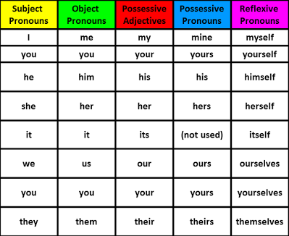

Rewrite the following paragraphs using appropriate pronouns.

James and Mary were siblings. One day James and Mary returned from school. James and Mary were very hungry and went straight into the kitchen. James and Mary wanted to eat something. In the kitchen James and Mary saw a cat. The cat was drinking the milk mother had kept for James and Mary. James ran out screaming. James was scared. James was always afraid of cats. Mary was a brave girl. Mary was not afraid of anything. Mary shooed the cat away. The cat ran out. James saw the cat running away. James came back into the kitchen. James praised Mary for Mary’s courage. Mary thanked James.

Determiners
Kinds of determiners
Nouns in English are preceded by one of the words from four classes called determiners:
- articles (a/an/the)
- quantifiers (some, few, many etc.)
- demonstrative adjectives (this house, those books etc.)
- possessive pronouns (its, his, her etc.)
- interrogatives (which, what etc.) (Which book is yours?)
When are they not used?
Determiners are not needed if:
- the noun is plural and indefinite (Girls are clever)
- if it is a mass noun (Water is important. Joy is contagious.)
- if it is a proper noun (Kandy, Manel)
Otherwise, all nouns have to be preceded by a determiner.
Articles
Rules for articles:
The
- The is used before a definite noun – a noun that is known about before.
(I saw the man yesterday – is said when who the man is, is known by the speaker and the listener)
- ‘The’ can be used with singular or plural definite nouns.
(The men were very noisy.)
- ‘The’ is always used before a noun if there is only one of its kind in the world. (the sun, the moon, the earth)
a/an
- If a singular noun is indefinite (not recognized from before) then ‘a’ can be used if the noun starts with a consonant sound, and ‘an’ if it starts with a vowel sound. (Remember, not the letter but the sound – that is why ‘uniform’ will be preceeded by ‘a’ and not ‘an’ – the sound is ‘yu’; and ‘honest man’ will be preceeded by ‘an’ because the ‘h’ is silent. )
- An indefinite plural noun does not need an article. (Girls are clever)
Exercises
- Put the appropriate article where necessary. Put a cross when an article is not needed.
- ............... student came to see me yesterday.
- .............. student was very upset.
- .......... name of the student had not been included in ............ register.
- ........... lecturer of the class had told her to speak with ............ Head of ............ Department.
- I checked with ........... clerk.
- ................. mistake had been made.
- ................. problem will be sorted out.
- ......................... problems like this are not serious, but we must make sure that ................................... students are not ........................... inconvenienced.
Quantifiers

Quantifiers are determiners (some of the following words are called pre and post determiners). We use quantifiers when we want to give someone information about the number of something: how much or how many.

Particular quantifiers precede particular nouns – especially important to remember are which quantifiers can precede count nouns and which quantifiers precede uncount nouns. Here are some common ones for you to remember.
Reading
Say I have a container with a bunch of water molecules

With plural count nouns

Several (people, children) – Several students spoke to me about this problem.
Plenty of – Plenty of people will want to buy this CD.
Hundreds of – Hundreds of birds flew to the sky from the trees.
Few (chairs, students, friends) – (not many is implied)
There are few chairs in the class room, so most of the students are standing.
A few (tables, bottles of water) - (not many but enough is implied.)
There are a few chairs in the classroom, so the students can sit.
Many (people/cups of tea) ..........................................................................................

With Singular count nouns

Every(means all) - Every child (All children love) loves his/her parents.
Each (means all) - Each student (All students are) is important.

With mass nouns

Much (tea, money) – I drank much tea yesterday as I worked.
Little (water, bread) – (not enough is implied.) –
There is little water in the river because of the drought.

A little (water, bread) – (enough is implied.)
There is a little water in the river to irrigate the fields.
a great deal of
(if you put the noun directly after this, you are referring to the whole group. If you put the article ‘the’ before it, you are referring to a specific group.)
A great deal of people came to the meeting.
A great deal of the people who came to the meeting were drunk.

a bit of .........................................................................................................................
a good deal of ..............................................................................................................

both count and uncount nouns

A lot of - I have a lot of money/ I have a lot of friends.
Some - I have some money / I have some good friends.
Most - Most politicians are corrupt./ Most of the water in this lake is polluted.
A lot of ...............................................................................................................
Lots of ................................................................................................................
All .......................................................................................................................
Any .....................................................................................................................
Enough ...............................................................................................................
No ........................................................................................................................
None of (the) ......................................................................................................
Some .....................................................................................................................

Numericals
Numbers (cardinal and ordinal - one, hundred, first, twentieth), multipliers (double, twice) fractions (one third) are also considered as quantifiers.

Two birds sat on the Mango tree.
Twice the number of people came for the second meeting.

Demonstrative Adjectives
Some common demonstrative adjectives are: this/that/these/those
I like this blanket (near the speaker) but not that one (more distant from the speaker).
Please give me two of these buns and three of those pastries.

Possessive Pronouns

With these, you do not have to use any other determiner:

My book, Our home, Your thesis, His idea, Her creation, Its tail, Their class

Prepositions

Read the two experiments given below and identify the use of prepositions

Look, No Hands

Blow up a balloon without using your mouth or your hands.
- Fill the glass bottle with warm-to-hot water. Let it sit for about 3 minutes so the bottle warms up.
- Pour cold water into the bowl until it’s about ³/4 full.
- Pour the warm water out of the bottle.
- Stretch the balloon over the top of the bottle.
- 5. Put the bottle into the bowl of water and watch what happens!
The balloon should inflate inside the bottle.

Why it happened:
As the air in the bottle cooled, it contracted and took up less space in the bottle. Air from outside the bottle rushed in to fill the space and inflated the balloon.

Build Your Own Volcano
- Color the vinegar with red food coloring.
- Put the baking pan (or cover) on the ground and place the soda bottle in the middle of it.
- Shape the moist soil (or sand) around the bottle to form a mountain. Bring the soil to the bottle's opening, but don't get the soil inside the bottle.
- Pour the baking soda into the bottle.
- Pour the colored vinegar into the bottle
Watch red foam spray out of the top and down the mountain like lava from a volcano.

Why it happened
The baking soda reacted with the vinegar to produce carbon dioxide gas. The gas built up enough pressure to push the foaming liquid out of the top of the bottle.

Task 01: When did it happen?
Complete the text
An Important Event

I was at/on/in __________________ (place) when it happened. It was at ___________ (time) on ___________ (day). It was in ___________ (month), in ___________ (year). I remember that I felt ___________ (how did you feel?).

Illustrating IN, AT, ON with gestures
- For IN:
Use your hands to make a circular gesture around yourself.
- For ON:
Hold one hand palm upwards, tap your palm with the tips of your fingers on your other hand.
- For AT:
Stand next to a chair, table or desk and point down at the desk.

When did it happen?
You can do the same text but change the title to read A frightening event/My happiest moment/My worst moment etc.

Where’s the best place to live?
Tell them to imagine a map of the city, town where you are teaching. Ask students to tell you where the best place to live in the city is. As students begin to tell you, elicit the following prepositional phrases: on … street, in the centre, in … neighbourhood, at the end of … street. Do the same activity with the following questions:
- Where’s the most dangerous part of the city?
- Where are the best restaurants/discos?
- What’s the most boring/ugliest part of the city?

Working times questionnaire:
Answer the questions. Write a time, day, month or year. Use the correct preposition.
- When do you leave for the university? _________
- When do you finish work? _________
- When do you have your holidays? _________
- When did you start working at the place you are now? _________
- When is the busiest time of year for you at work? _________
- When is the slowest time of year for you at work? _________

Check Your Calendar
Have students fill out a calendar with either real or fictional events in their lives. Then, have pairs discuss what they will be doing and at what times. Students should choose the appropriate preposition of time for each event during their discussion times.
Give the 5 minutes to complete this individually
Task 02: Reading
Fill in the blanks to complete the story.
The town of Hamlyn was once full ………….. rats. They ate all the food, troubled sleeping babies, and made a lot …………. noise. The people had grown tired ………… the rats but were unable …………. do anything. Even the cats were not able to kill the rats.
One day, a queer fellow ……………. piercing eyes, came to town. He was called the Pied Piper. He went ………… the Mayor and asked him, “What will you pay me if I free your town of every single rat?” The mayor offered fifty pounds ………….the Pied Piper.
Happy …………… the offer, the Pied Piper started playing his pipe. Hearing the shrill, keen note, every rat came out ………….. its hole and started following him. The Pied Piper kept …………. playing his pipe and the rats followed him. The piper walked up ……. the harbour ………… millions …………rats …………… him and led them ………. the water and waited till every rat had drowned.
Now the town was free of the little devils and the people were very happy.
After all the rats were dead, the Pied Piper returned and asked the Mayor ……….. his money. The Mayor said that he could only give him twenty pounds ………….. such an easy job. Now that the rats were dead, the Mayor thought that there was nothing to worry ……………. But the Pied Piper wanted ………….to teach him a lesson. This time he played a different tune. Hearing his music, the children came out …………. their houses. They started following the piper, dancing and shouting. The elders watched ……….. disbelief as the Pied Piper led the children far, far away. The Mayor sent his men to look ………. the piper and bring the children back but none could find the lost children.

Simple Prepositions
Task 03
Discuss appropriate prepositions that can be used to describe the position of each image.
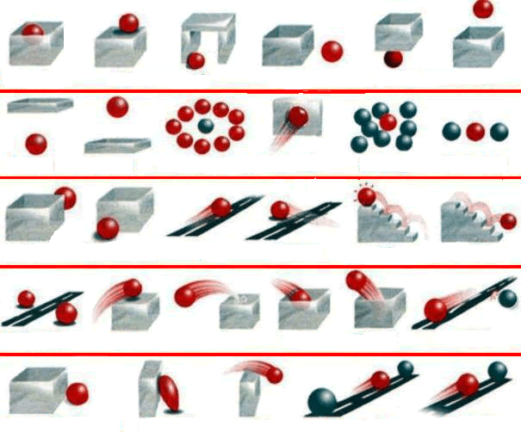

Phrase Prepositions
Form sentences using phrase prepositions given below.
- According to
According to scientists, the Sun and all the planets of our Solar System began as a giant cloud of molecular gas and dust.
…………………………………………………………………………………………………..

- Along with
The committee read out the names of scientists along with their discoveries.
…………………………………………………………………………………………………..
- In lieu of
Alternative laboratory testing methods in lieu of the authentic testing methods were used to prove the hypothesis.
He accepted the car in lieu of his claim of Rs.54000.00.
…………………………………………………………………………………………………..
- On behalf of
On behalf of the members, he agreed to participate in the event.
…………………………………………………………………………………………………..
- By means
By means of rope ladders, they scaled the wall.
…………………………………………………………………………………………………..
- On account of
On account of his negligence, the company lost the project.
…………………………………………………………………………………………………..
- In spite of
He persevered in spite of difficulties.
…………………………………………………………………………………………………..
- With reference to
This is with reference to the letter dated 22nd January 2016
With regard to your letter dated 23 November 2017 concerning garbage disposal around the university of Sri Jayewardenepura, I hereby inform you the decisions taken by the council.
…………………………………………………………………………………………………..
- In order to
The authorities reattempted to study the case in order to expedite the process
…………………………………………………………………………………………………..
Task 04
Fill the gaps using prepositions.
1. Gajanayaka died as a result _______ a heart attack.
2. He almost died due _______ lack of oxygen.
3. _______ view of the shortage of time, each person may only speak for five minutes.
4. He politely made no reference _______ my untidy appearance.
5. Police want to talk to him in connection _______ his wife’s disappearance.
6. Looking at it _______ a scientific point of view, the discovery is extremely important.
7. The techniques used differ _______ company to company.
8. The town of Gouda is famous _______ its cheese.
Task 05
Construct sentence using following nouns/objectives with prepositions after them.
Category 01 (of) Noun+ of
Experience, assurance, proof, failure, result
Category 02 (to) Noun+ to
Alternative, limit, attachment, disgrace, encouragement, reference
Category 03 (to) Adjective+ to
Obedient, opposite, relevant, responsible, partial, reduced, indifferent, equal
Category 04 (with) Adjective+ with
Contended, overcome, infected, satisfied, inspired, popular
Category 05 (for) Adjective+ for
Anxious, ready, sorry, useful, prepared, qualified, sufficient
Category 06 (from) Verb+ from
Deviate, differ, prevent, escape, prohibit, recover, exclude, refrain
Category 07 (for) Noun + for
Ambition, passion, opportunity, reputation, esteem, motive, partiality
Category 08 (on) Verb + on
Comment, depend, impose, insist, dwell, resolve, decide
Category 09 Verb + for
Feel, wish, care, start, yearn, hope
Category 10 Verb + in
Excel, increase, involve, employ, fall, glory, indulge, persist
Category 11 Verb + with
Sympathise, part, fill, associate, correspond, coincide, dispense
Category 12 Verb + of
Die, despair, disapprove, beware, dream, judge, complain
Speaking
Desert Island Activity
Get into groups. Take a piece of paper and draw an item. Assume that you have been stranded on a desert island, and only one group can survive and continue to inhabit the desert island. Your goal is to convince the class that your group should survive. The hard part is that the only thing you have is an item that was drawn a few minutes earlier on a piece of paper.
Write the steps of the given experiment using imperatives. Fill blanks using appropriate prepositions.
Procedure –

First, you need ………. clean and dry a 50-mL beaker. Then, you need to obtain the mass of this empty beaker ……… the analytical balance. After that you should record this information in the data table ………. the Student Report. Then the beaker should be filled to about the 10-mL mark ………… dry copper shot found in the laboratory. Then, your 25-mL graduated cylinder is filled …….. distilled water to about the 10-mL mark. Then, the volume is read and recorded ………. the nearest 0.01 mL. Be sure to read to the bottom ……… the meniscus and keep your eye level even ……….. the liquid level.
A funnel is used to slowly add the shot from the beaker to the graduated cylinder. You should be careful not to splash the water ………. of the cylinder. The cylinder is gently tapped while adding the shot to release any trapped air bubbles. When all the shot is added and you have removed the trapped air bubbles (as best you can), you can read and record the liquid level ……. the cylinder again. Remember to estimate the volume to the nearest 0.01 mL. A thermometer is used to measure the temperature of the water, estimating to the nearest 0.1 °C. The temperature is recorded ……… the data table. After completing the second trial ………. the copper shot, the same experiment is repeated, but two trials are performed using aluminum shot and two trials using lead shot.

Vocabulary in use
Distilled water, obtain, tap, estimate, measure, funnel, volume, analytical, record, equipment, require

How to read numbers
Group work: Can you read these numbers?
1,000,000
10,000,000
100,000,000
1,000,000,000
Digits
105 is a three-digit number. The digits are 1, 0, and 5.
28 ends in the digit 8.
$364 has the same digits as $3.64.

Number Ten is a collection of ten Ones.
One Hundred is a collection of ten Tens.


The Powers of 10
Class of | One | 1
Ones | Ten | 10
 | Hundred | 100
Class of | One thousand | 1,000
Thousands | Ten thousand | 10,000
 | Hundred thousand | 100,000
Class of | One million | 1,000,000
Millions | Ten million | 10,000,000
 | Hundred million | 100,000,000
Class of | One billion | 1,000,000,000
Billions | Ten billion | 10,000,000,000
 | Hundred billion | 100,000,000,000

Each power is composed of ten of the one above.
Strictly, 1 is not a power of 10. The first power of 10 is 10 itself. Its numeral is a 1 followed by one 0. The second power of 10 is 100; it has two 0's. The third power has three 0's. And so on.
Notice how the names fall into groups of three:
One thousand, Ten thousand, Hundred thousand.
One million, Ten million, Hundred million.

Write each number in words.
- 120, 000 –One hundred twenty thousand
- 202,000,016 – Two hundred two million, sixteen
- 800,060,003,012 – Eight hundred billion, sixty million, three thousand, twelve
- 67,000,020,000 – Sixty-seven billion, twenty thousand
Write each number in numerals
- Five hundred thirty six
- Two thousand twenty-four
- Eight hundred twelve million, four hundred seventy-one – 812,000,471
say "a" instead of "one" beforehundred, thousand, etc. and they often add"and" before the last number: a hundred and twenty-one, a thousand and eleven / etc.

